Problem 1 Output:-

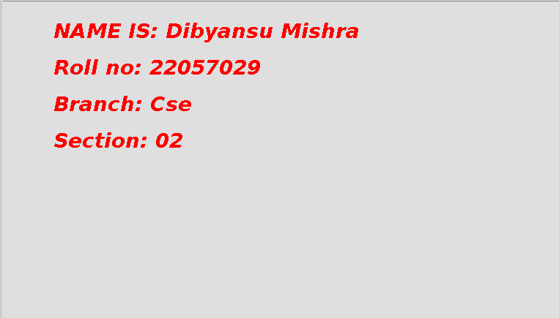

Problem2 Output: -



Problem 3 Output: -

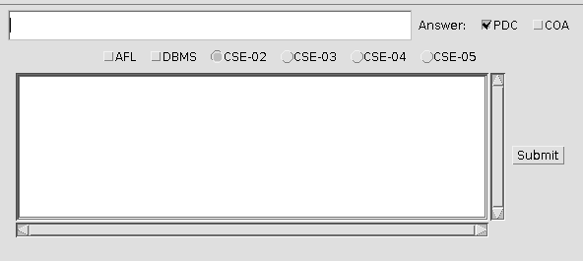

Problem 4 Ouput: -

